Top Level Drop Downs:
1) General Legal Requests
2) Vendor Contract Request
3) Sales Contract Request
4) NDA
5) Privacy/AI Matters
6) Business Development Request

Drop Downs expanded: [NOTE * Means Response to Question/Field is Required]
[Screenshots provided for default view of each request template]

General Legal Request
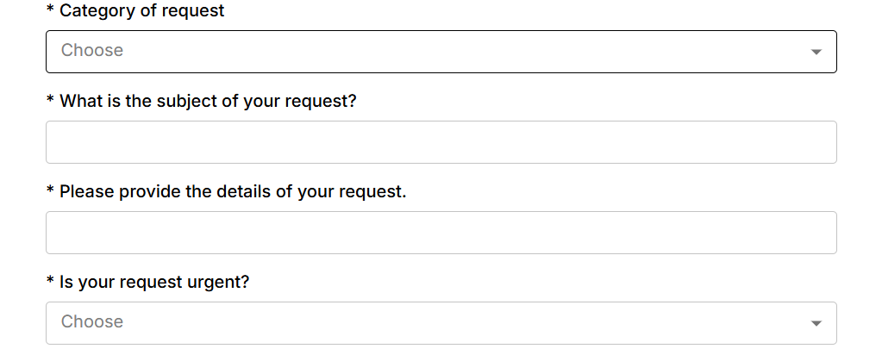
- *Category of Request [Drop Down]
- Accounting/ Finance
- Business Development
- Compliance/ Regulatory
- Corporate
- Current Sales Contract Interpretation/ Question
- Current Vendor Contract Interpretation/ Question
- Cybersecurity Questions (Non-Questionnaires)
- Development & Product
- EDI
- Facilities/ Leases
- HR [*]
- Insurance
- Intellectual Property (IP)
- IT
- Marketing
- Mergers & Acquisitions
- Other Legal Matter
- Pre-Sales & Post- Sales Questionnaires
- Pre-Sales Questions
- Subpoena/ Dispute/ Investigation/ Litigation/ Arbitration

[* - New drop down if HR is selected “HR Matter” 3 options listed below]
1k) *HR Matter [Drop Down]
a. Benefits
b. Employee Performance/ Termination
c. All Other HR

- *What is the subject of your request? [Free Text Field]
- *Please provide the details of your request. [Free Text Field]
- *Is your request urgent? [Drop Down]
- Yes
- No

- Attach any supporting documents to this email. [No drop down or text field – just put as a direction to user]

Vendor Contract Request
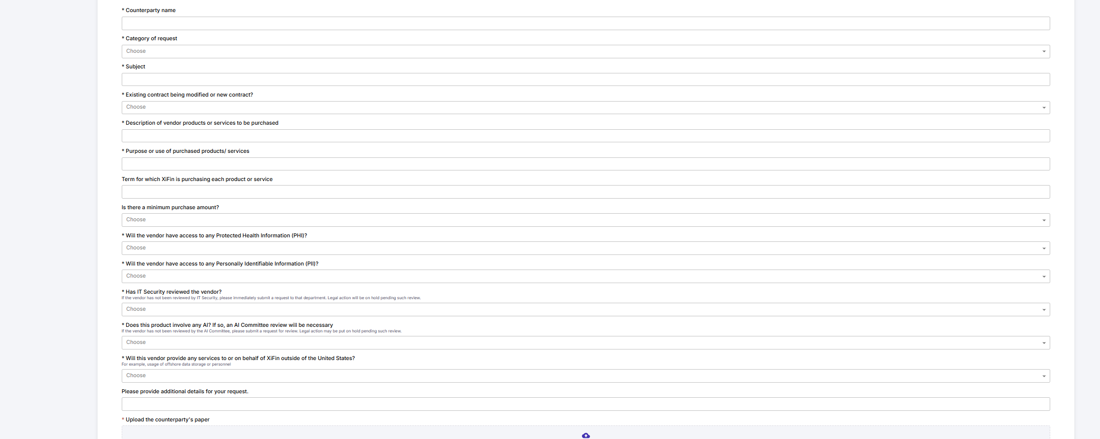
1) *Counterparty name [Free text field]
2) *Category of request [Drop Down]
- Accounting/ Finance
b. Billing Services
c. Business Development
d. Compliance/ Regulatory
e. Corporate
f. Cybersecurity
g. EDI
h. Facilities/ Leases
i. HR
j. Insurance
k. IT/ Software
l. Intellectual Property (IP)
m. Marketing
n. Mergers & Acquisitions
o. Other vendor contract not listed here
p. Technical Services
3) *Subject [Free text field]
4) *Existing contract being modified or new contract? [Drop Down]
  - Existing contract [*]
  - New contract

[*] If the response to “Existing contract being modified or new contract?” is “Existing contract”, THEN the field “Describe or attach the existing contract being modified” is shown.
4a) Describe or attach the existing contract being modified [Free text field]
5) *Describe or attach the existing contract being modified [Free text field]
6) *Description of vendor products or services to be purchased [Free text field]
7) *Purpose or use of purchased products/ services [Free text field]
8) Term for which XiFin is purchasing each product or service [Free text field]
9) Is there a minimum purchase amount? [Drop Down]
a. Yes [*]
b. No
[*] If the response to “Is there a minimum purchase amount?”
is “Yes”, THEN the field “What is the minimum spend?” is shown.

9a) What is the minimum spend?

10) *Will the vendor have access to any Protected Health Information (PHI)? [Drop Down]
a. Yes
b. No

11) *Will the vendor have access to any Personally Identifiable Information (PII)? [Drop Down]
a. Yes
b. No

12) *Has IT Security reviewed the vendor?
If the vendor has not been reviewed by IT Security, please immediately submit a request to that department. Legal action will be on hold pending such review. [Drop Down]
a. Yes
b. No

13) *Does this product involve any AI? If so, an AI Committee review will be
necessary
If the vendor has not been reviewed by the AI Committee, please submit a request for review. Legal action may be put on hold pending such review.
[Drop Down]
a. Yes
b. No
14) *Will this vendor provide any services to or behalf of XiFin outside of the United States?
For example, use of offshore data storage or personnel
[Drop Down]
a. Yes
b. No
15) Please provide additional details for your request. [Free text field]
16) *Attach the counterparty's paper to this email [No drop down or text field – just put as a direction to user]

Sales Contract Request
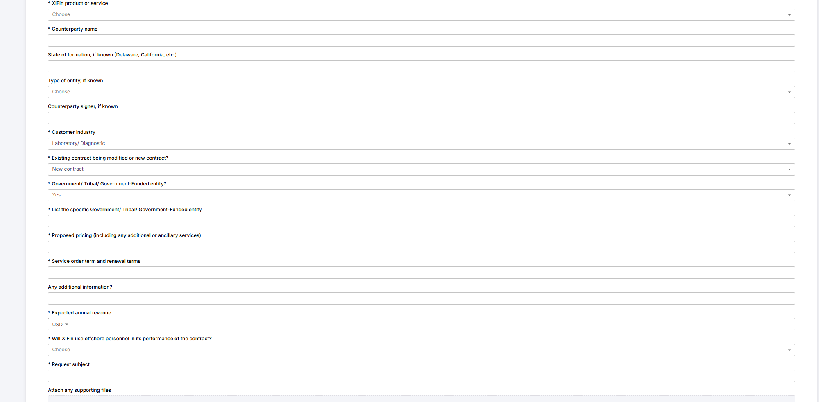
- *XiFin product or service [Drop Down]
a. AI Products
b. Billing Services (formerly OSB)
c. CareAlerts
d. Empower LIS
e. Empower RCM (formerly RPM)
f. Encounter- Rx
g. Fusion Rx
h. Other XiFin not listed
i. Pharmacy Essentials (formerly known as CareCLAIM)
j. Pharmacy Essentials (as a component of Pharmacy Enterprise)
k. Radiology (not on Empower RCM XiFin RPM)
l. SaaS+ Services added to Empower RCM
m. Strand
2) *Counterparty name [Free text field]

3) State of formation, if known (Delaware, California, etc.) [Free text field]

4) Type of entity, if known [Drop Down]
  - Corporation
  - LLC
  - Other [*]
[*]If the response to “Type of Entity” is “Other”, THEN the field “If ‘Other’, please specify” is shown.
4c) *If “Other”, please specify [Free text field]

5) Counterparty signer, if known
[Free text field]
6) *Customer industry [Drop Down]
a. Hospital/ Medical System
  - Laboratory/ Diagnostic
  - Med Device
  - Other
  - Pharmacy
  - Radiology
  - Specialty Pharmacy
  - Specialty Physician
7) *Existing contract being modified or new contract? [Drop Down]
a. Existing contract [*]
b. New contract
[*]If the response to “Existing contract being modified or new contract?” is “Existing contract”, THEN the field “Describe or attach the existing contract being modified” is shown.
7b) *Describe or attach the existing contract being modified [Free text field]

8) *Government/ Tribal/ Government-Funded entity? [“Select” field with the
following options]
a. Yes [*]
b. No
[*]If the response to “Government/ Tribal/ Government-Funded entity?” is “Yes”, THEN the field “List the specific Government/ Tribal/ Government-Funded entity” is shown.
8a) *List the specific Government/ Tribal/ Government-Funded entity [Free text field]

9) *Proposed pricing (including any additional or ancillary services) [Free text field]
10) *Service order term and renewal terms [Free text field]
11) Any additional information? [Free text field]
12) *Expected annual revenue
[Free text field]

13) *Will XiFin use offshore personnel in its performance of the contract? [Drop Down]
a. Yes
b. No
14) *Request subject
[Free text field]

15) Attach any supporting files to this email [No drop down or text field – just put as a direction to user]

NDA
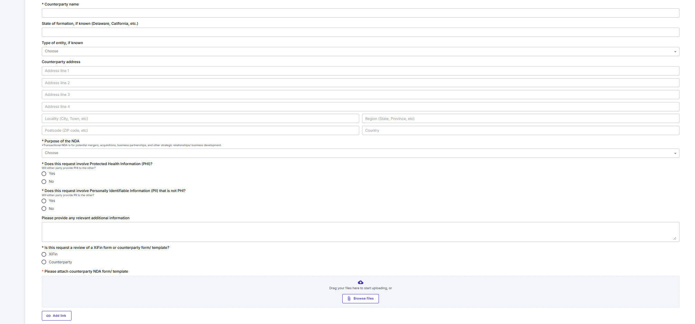
1) *Counterparty name [Free text field]
2) State of formation, if known (Delaware, California, etc.) [Free text field]
3) Type of entity, if known [Drop Down]
  - Corporation
  - LLC
  - Other [*]

[*]If the response to “Type of Entity” is “Other”, THEN the field “If Other please specify” is shown.
3c) If “Other”, please specify [Free text field]

4) Counterparty address [Free text field]
5) *Purpose of the NDA
Transactional NDA is for potential mergers, acquisitions, business partnerships, and other strategic relationships/ business development [Drop Down]
a. Sales prospect
b. Existing customer
c. Vendor
d. Transactional

6) *Does this request involve Protected Health Information (PHI)? [Drop Down]
a. Yes [*]
b. No

[****] If the response to “Does this request involve Protected Health Information (PHI)? Is “Yes”, THEN TWO (2) NEW fields shown:
6a-1) *Please explain why PHI is necessary for this request [Free text field]
6a-2) *Which party will be providing PHI? [“Checkbox” field with the following options]
a. XiFin
b. Counterparty
c. Third Party [**]
[**]If the response to “Which party will be providing PHI?” is “Third Party”,
THEN the field “Who is the third party receiving PHI?” is shown.
6a-2c-1) *Who is the third party receiving PHI? [Free text field]

7) *Does this request involve Personally Identifiable Information (PII) that is not PHI? [Drop Down]
a. Yes [*]
b. No

[*] If the response to “Does this request involve Personally Identifiable Information (PII) that is not PHI?” is “Yes”, THEN the field “Which party will be providing PII?” is shown.
7a) *Which party will be providing PII? [“Checkbox” field with the following options]
a. XiFin
b. Counterparty
c. Third Party [*]
[*]If the response to “Which party will be providing PII?” is “Third Party”,
THEN the field “Who is the Third Party receiving PII?” is shown.
7a-c-1) *Who is the third party receiving PII? [Free text field]

8) Please provide any relevant additional information [Free text field]
9) *Is this request a review of a XiFin form or counterparty form/ template? [Drop Down]
a. XiFin
b. Counterparty [*]
[*]If the response to “Is this request a review of a XiFin form or counterparty form/ template?” is “Counterparty”, THEN the field “Have you asked the counterparty to use the XiFin form/ template?” is shown.
9b) *Have you asked the counterparty to use the XiFin form/ template? [Drop Down]
a. Yes
b. No
10) *Please attach counterparty NDA form/ template to this email. [No drop down or text field – just put as a direction to user]

Privacy/AI Matters
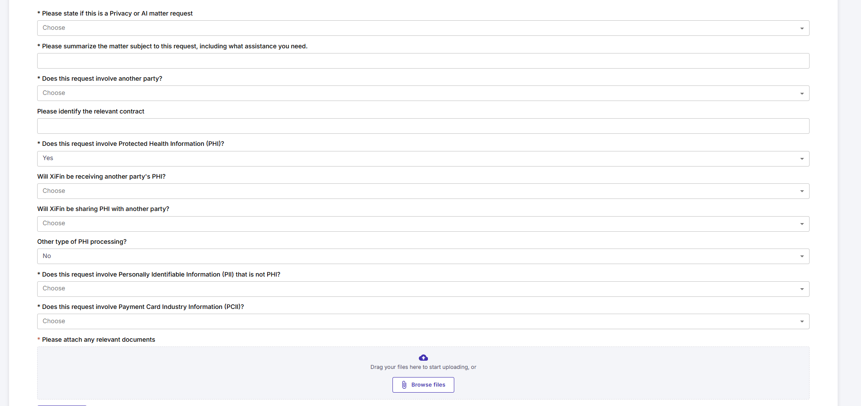
1) *Please state if this is a Privacy or AI Matter request [Drop Down]
  - Privacy related matter [*]
b. Artificial Intelligence related matter [**]

[*]If the response to “Please state if this is a Privacy or AI Matter request is “Privacy related matter” THEN the field “Privacy related matter” is shown

1a) *Privacy related matter [Drop Down]
a. Data subject access request
b. Customer request relating to privacy
c. Product/development related request relating to privacy
d. Billing services request relating to privacy
e. Audit related privacy request

[**]If the response to “Please state if this is a Privacy or AI Matter request is “Artificial Intelligence related matter” THEN the field “Artificial Intelligence related matter” is shown

1b)*Artificial Intelligence related matter [Drop Down]
a. New AI Tool for internal XiFin use
b. Change in previously approved AI tool for internal XiFin use
c. New AI product or service to be used for XiFin customers
d. Change in AI product or service to be used for XiFin customers
e. Vendor AI use
f. Other AI related matters

2) *Please summarize the matter subject to this request, including what assistance you need. [Free text field]

3) *Does this request involve another party? [Drop Down]
a. Yes [*]
  - No

[*] If the response to “Does this request involve another party?” is “Yes”, THEN the field “What type of party does this request involve?” is required.
3a) *What type of party does this request involve? [Drop Down]
a. Customer
b. Vendor
  - Other party[**]

[**]If the response to “What type of party does this request involve?” is “Other party” THEN TWO (2) fields:

3a-c-1) *Please name the type of relationship with the other party [Free text field]

3a-c-2 ) *Is there a contract in place with the other party? [Drop Down]
a. Yes
b. No

4) Please identify the relevant contract [Free text field]
5) *Does this request involve Protected Health Information (PHI)? [Drop Down]
a. Yes [*]
b. No

[*]If the response to “Does this request involve Protected Health Information (PHI)?” is “Yes”, THEN THREE (3) NEW fields:

5a-1) Will XiFin be receiving another party's PHI? [Drop Down]
- Yes
- No

5a-2) Will XiFin be sharing PHI with another party? [Drop Down]
- Yes
- No

5a-3) Other type of PHI processing? [Drop Down]
a. Yes [**]
b. No

[**] If the response to “Other type of PHI processing?” is “Yes”, THEN the field “Please explain the other type of PHI processing” is shown.

5a-3-a-1) Please explain the other type of PHI processing [Free text field]

6) *Does this request involve Personally Identifiable Information (PII) that is not PHI? [Drop Down]
  - Yes [*]
  - No

[*] If the response to “Does this request involve Personally Identifiable Information (PII) is “Yes”, THEN the the following THREE (3) fields are shown.

6a-1) Will XiFin be receiving another party's PII? [Drop Down]
a. Yes
b. No

6a-2) Will XiFin be sharing PII with another party? [Drop Down]
- Yes
- No
6a-3) Other type of PII processing? [Drop Down]
a. Yes [**]
b. No

[**] If the response to “Other type of PII processing?” is “Yes”, THEN the field “Please explain the other type of PII processing” is shown.

6a-3-a) Please explain the other type of PII processing [Free text field]

7) *Does this request involve Payment Card Industry Information (PCII)? [Drop Down]
- Yes [*]
- No

[*] If the response to “Does this request involve Payment Card Industry Information (PCII)?” is “Yes”, THEN the field “Please describe XiFin’s processing and exchange of PCII?” is shown.

7a) *Please describe XiFin’s processing and exchange of PCII [Free text field]

8) *Please attach any relevant documents to this email. [No drop down or text field – just put as a direction to user]

Business Development Request
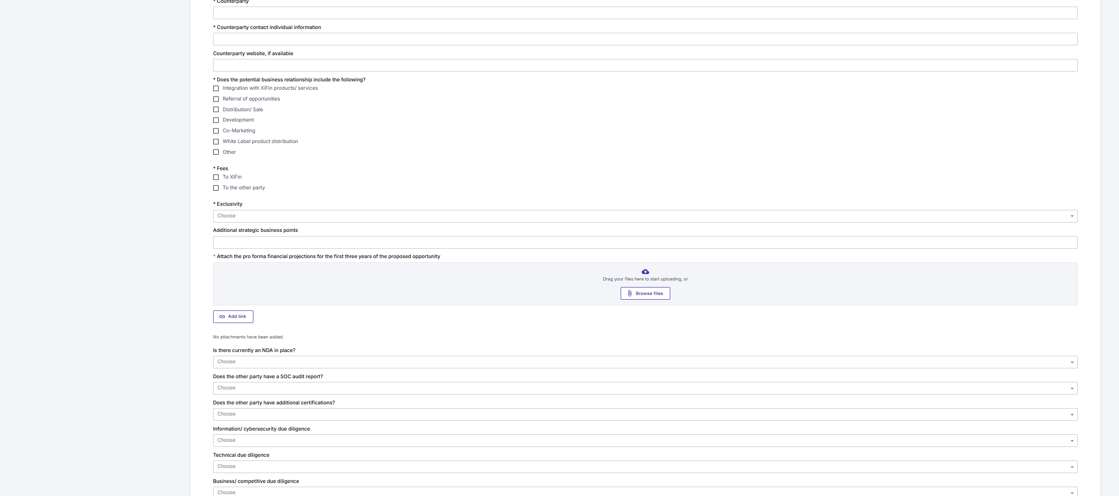
1) *Counterparty
[Free text field]
2) *Counterparty contact individual information
[Free text field]
3) Counterparty website, if available
[Free text field]
4) *Does the potential business relationship include the following?
[“Checkbox” field with the following options]
- Integration with XiFin products/ services [*]
- Referral of opportunities [**]
- Distribution/ Sale [***]
- Development
- Co-Marketing
- White Label product distribution [****]
- Other [*****]

[* ]If the response to “Does the potential business relationship include the following?” is “Integration with XiFin products/ services”, THEN the field “Products/ services to be integrated” is shown.

4a) *Products/ services to be integrated [“Checkbox” field with the following options]
- AI Products
b. Billing Services (formerly OSB)
c. CareAlerts
d. Empower LIS
e. Empower RCM (formerly RPM)
f. Encounter- Rx
g. Fusion Rx
h. Other XiFin not listed
i. Pharmacy Essentials (formerly known as CareCLAIM)
j. Pharmacy Essentials (as a component of Pharmacy Enterprise)
k. Radiology (not on Empower RCM XiFin RPM)
l. SaaS+ Services added to Empower RCM
m. Strand

[**] If the response to “Does the potential business relationship include the following?” is “Referral of opportunities”, THEN the field “Referral of opportunities” is shown.
4b-1) *Referral of opportunities [Drop Down]
- To XiFin [*]
- To the other party [**]

4b-2) Describe compensation
[Free text field]
4b-3) *List of products/ services
[Free text field]

[***] If the response to “Does the potential business relationship include the following?” is “Distribution/ Sale”, THEN the field “Resale” is shown.
4c) Resale [Drop Down]
- By XiFin
- By Counterparty

[**** ]If the response to “Does the potential business relationship include the following?” is “White Label product distribution”, THEN the field “Resale” is shown.

4f) Resale [Drop Down]
- By XiFin
- By Counterparty

[*****] If the response to “Does the potential business relationship include the following?” is “Other”, THEN the field “Please describe the other potential business relationship between the parties” is shown.

4g) Please describe the other potential business relationship between the parties [Free text field]

5) *Fees [“Checkbox” field with the following options]
- To XiFin
- To the other party

6) *Exclusivity [Drop Down]
- In favor of XiFin
- In favor of the other party [*]

[*] If the response to “Exclusivity” is “In favor of the other party”, THEN the field “Has XiFin’s CEO approved exclusivity in favor of the other party?” is shown.

6b) *Has XiFin’s CEO approved exclusivity in favor of the other party?
[Drop Down]
a. Yes
b. No

7) Additional strategic business points
[Free text field]

8) *Attach the pro forma financial projections for the first three years of the proposed opportunity to this email. [No drop down or text field – just put as a direction to user]

9) Is there currently an NDA in place? [Drop Down]
- Yes
- No

10) Does the other party have a SOC audit report? [Drop Down]
- Current SOC 1
- Current SOC 2
- Both

11) Does the other party have additional certifications? [Drop Down]
a. HITRUST
b. ISO
- Penetration test (Pentest)
- Vulnerability test
- Other

12) Information/ Cybersecurity due diligence [Drop Down]
- Performed
- To be performed

13) Technical due diligence [Drop Down]
- Performed
- To be performed

14) Business/ competitive due diligence [Drop Down]
- Performed
- To be performed

